**LOAN MANAGEMENT SYSTEM**

USECASE DIAGRAM:

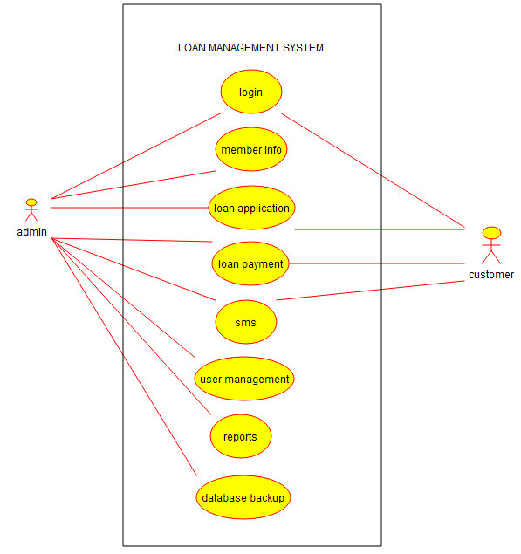

STATE DIAGRAM:

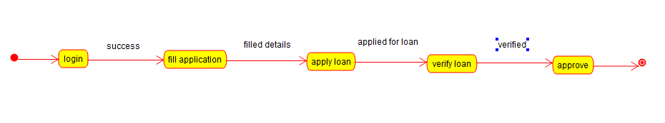

CLASS DIAGRAM:

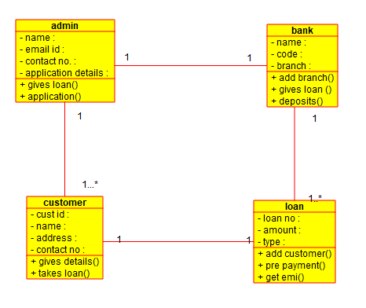

ACTIVITY DIAGRAM:

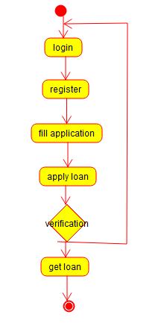

DEPLOYMENT DIAGRAM:

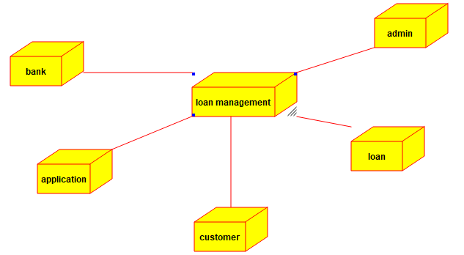

COMPONENT DIAGRAM:

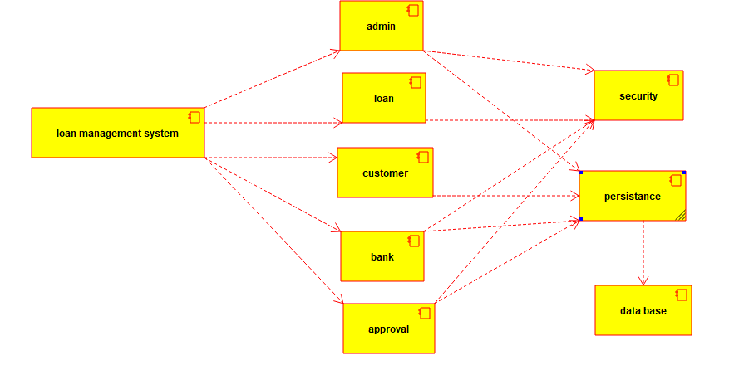

SEQUENCE DIAGRAM:

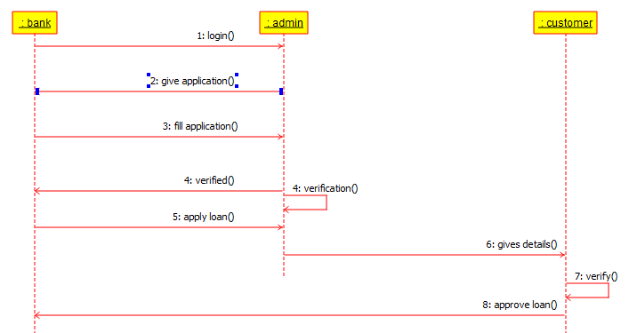

**VEHICLE BOOKING SYSTEM**

CLASS DIAGRAM:

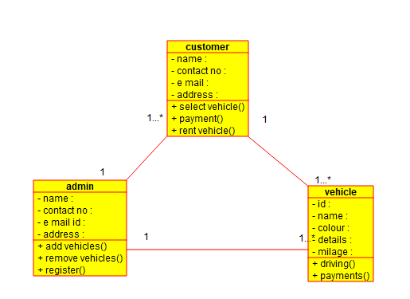

USE CASE DUAGRAM:

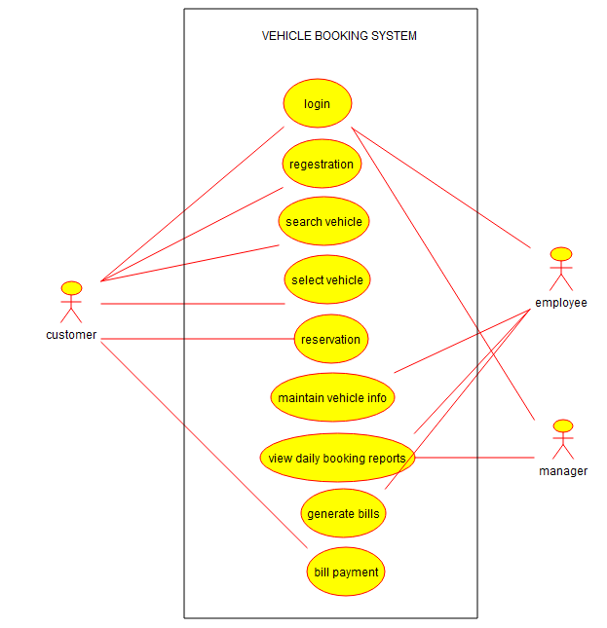

STATE DIAGRAM:

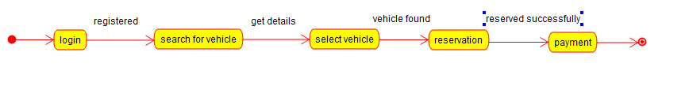

DEPLOYMENT DIAGRAM:

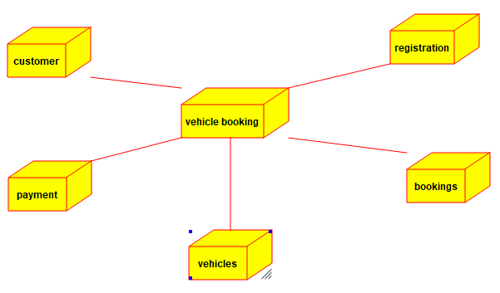

ACTIVITY DIAGRAM:

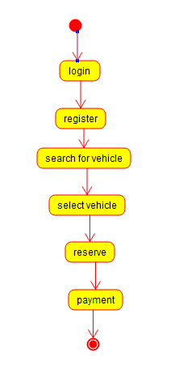

COMPONENT DIAGRAM:

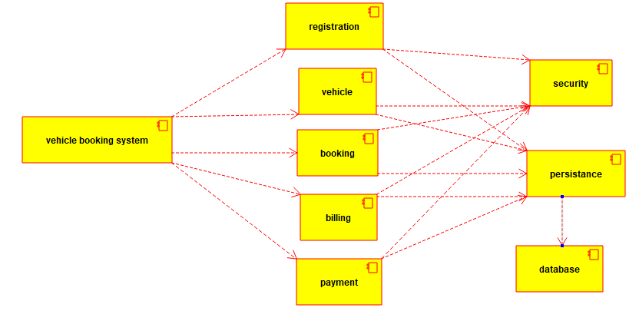

SEQUENCE DIAGRAM:

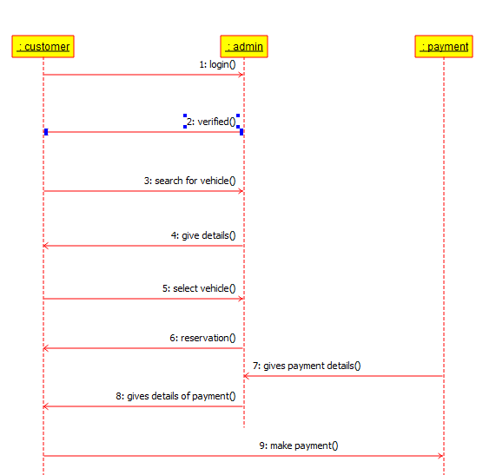

**DOCTOR APPOINTMENT SYSTEM**

USE CASE DIAGRAM:

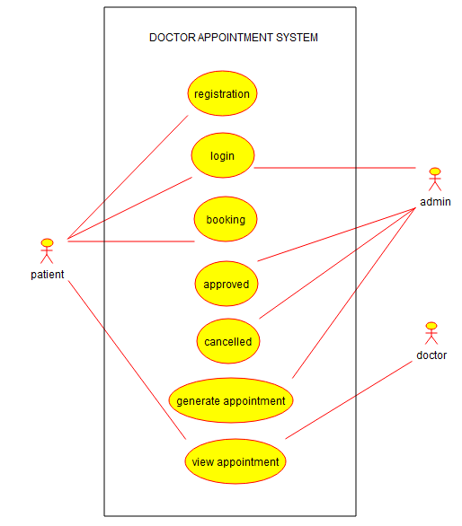

STATE DIAGRAM:

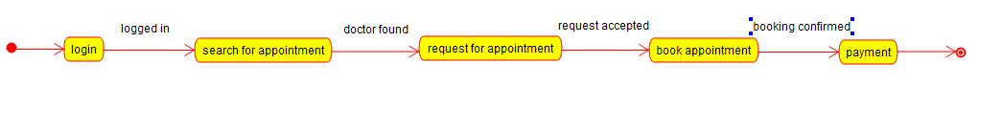

DEPLOYMENT DIAGRAM:

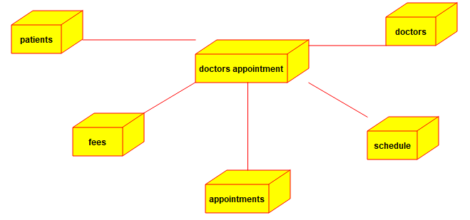

CLASS DIAGRAM:

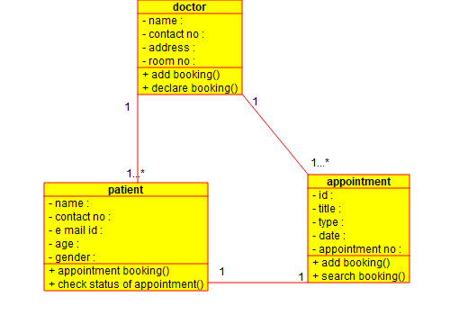

ACTIVITY DIAGRAM:

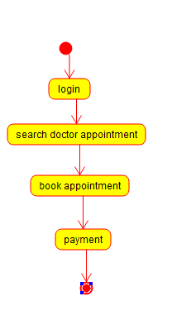

DEPLOYMENT DIAGRAM:

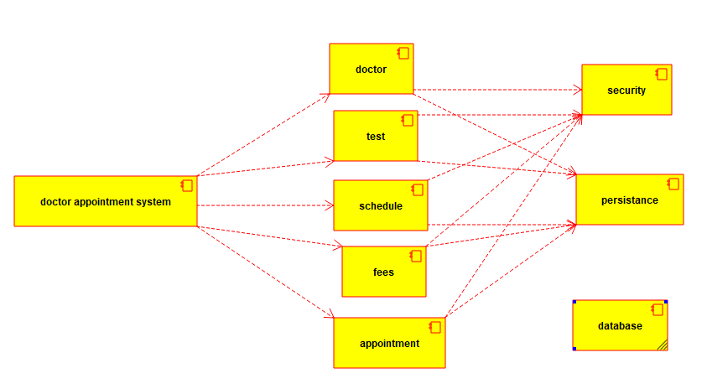

SEQUENCE DIAGRAM:

